IFG Challenge 2nd Year Easter – Awardz Night Spiritual
One Week Programme

Aim: To have an Easter theme fun night which includes parents, family and church members.
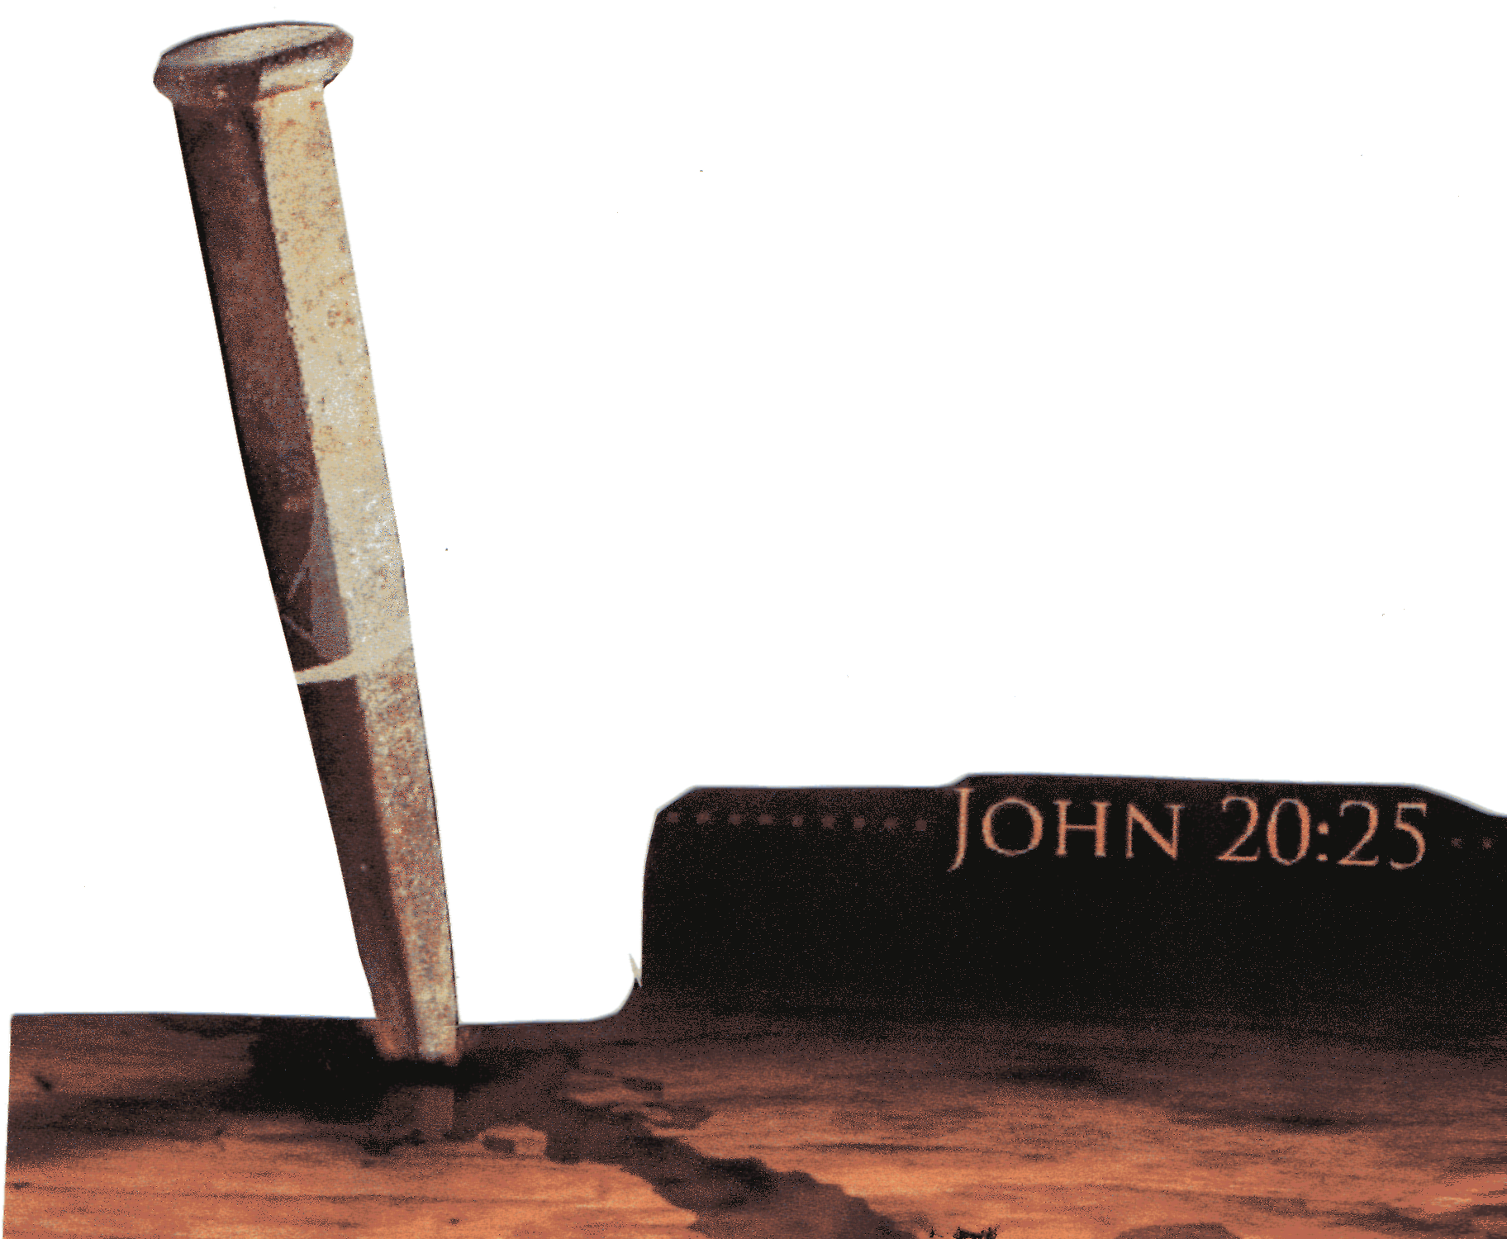
Objectives:
- To focus on the stations of the cross – Good Friday. interactive/award night.
John 20:25

Preparations:
- Decorate the meeting place - design / paint /procure a backdrop to depict the Calvary hill with 3 crosses.
- Send notices home the previous week encouraging everyone to come.
- Gather all equipment needed for the various activities.
- Food for supper

Welcome everyone and introduce the format for the evening.

Devotions: Stations of the Cross
Traditionally there are fourteen Stations of the Cross used in the Catholic Church but Protestants commonly use just eight:

Station 1: Pilate Condemns Jesus to Die
Station 2: Jesus Accepts His Cross
Station 3: Simon Helps Carry the Cross
Station 4: Jesus Speaks to the Women
Station 5: Jesus Is Stripped of His Garments
Station 6: Jesus Is Nailed to the Cross
Station 7: Jesus Cares for His Mother
Station 8: Jesus Dies on the Cross
You could base your evening’s activities on these.
Either begin by reading from a children’s bible of the Good Friday events; or you may be able to get a group from church to act out this event or read and explain each station before you do each activity.

Activities:
Cross Relay
Equipment needed:
- 2 pieces of wood per team that would form a cross (e.g. trellis slats) One of these pieces needs to be long enough so it can be dragged along the ground.
- Nails
- Hammer per team
Instructions:
Girls are to assemble the pieces of wood to form a cross. They are to be nailed in the centre with 2 nails. Once this is completed, they then take turns to carry the cross from one end of the hall to the other and back to their team mates. The next person takes over. Once everybody has had a turn, the team is finished and can sit down.

Ripping of clothes
Equipment needed:
- Material (1 piece per team – all the same size and same fabric) Minimum size of 1m x 1m.
Instructions:
As the soldiers did with Jesus’ clothes, the teams tear the material into as many pieces as they possibly can. The team that manages to get the most pieces wins.

Crown of Thorns
Equipment needed:
- Cane or vines suitable for moulding / weaving / intertwining into a crown.
- Pair of scissors / cutters on hand if needed
Instructions:
Each team to make a crown.

Presentation of Awards to the girls

Supper

Thanksgiving and Closing prayer

Notices for next term:
Give out the starting date for next term and a little taste as to what badges they will be doing.

Closing Prayer

Home Time

Extra Resource:

Nails
In engineering, woodworking and construction, a nail is a pin-shaped, sharp object of hard metal or alloy used as a fastener. Formerly wrought iron, today's nails are typically made of steel, often dipped or coated to prevent corrosion in harsh conditions or improve adhesion. Ordinary nails for wood are usually of a soft, low-carbon or "mild" steel (about 0.1% carbon, the rest iron and perhaps a trace of silicon or manganese). Nails for concrete are harder, with 0.5-0.75% carbon.^{[citation needed]}
Nails are typically driven into the workpiece by a hammer, a pneumatic nail gun, or a small explosive charge or primer. A nail holds materials together by friction in the axial direction and shear strength laterally. The point of the nail is also sometimes bent over or clinched after driving to prevent loosening.
Nails are made in a great variety of forms for specialized purposes. The most common is a wire nail. Other types of nails include pins, tacks, brads, and spikes.
Nails go back at least to the Ancient Roman period. The provision of iron for nails by King David for Solomon's Temple is mentioned in the Bible.^{[1]} Until the end of the 18th century, they were made by hand, an artisan known as a Nailer providing them with a head and point. Until the early 17th century there were workmen called Slitters who cut up iron bars to a suitable size for Nailers to work on, but in 1590 the slitting mill was introduced to England, providing a mechanical means of producing rods of uniform cross-section. In the 19th century, after the invention of machines to make "cut nails", some nails continued to be made by hand, but the handmade nail industry gradually declined and was largely extinct by the end of that century.
Manufactured cut nails were first introduced in America at the end of the 18th century. Cut nails are machine-cut from flat sheets of steel (originally iron). They are also called square nails because of their roughly rectangular cross section. Though still used for historical renovations, and for heavy-duty applications, such as attaching boards to masonry walls, cut nails are much less common today than wire nails.

